*i. File -> New -> VxWorks Downloadable Kernel Module Project*

ii. Finish the Wizard

iii. Delete second build-target named <project-name>_partialImage

iv. Delete reference to <project-name>_partialImage from first build target

v. Copy your Component folder under your newly created project.

*vi. Right click on the project -> Refresh*

*vii. Right click on the build target -> Edit content*

viii. Select your source file (CmpTest.c) and press „Add“

*ix. Right click on the project -> Build Options -> Set Active Build Spec...*

x. Select the corresponding build specification for your platforms (Note, that we only support the GNU compiler)

Armarch7_gnu

*i. Right click on build target -> Properties*

ii. Change to „Build Properties“ Tab

iii. Add the following Define: 1. -DMIXED_LINK (that’s always necessary in VxWorks)

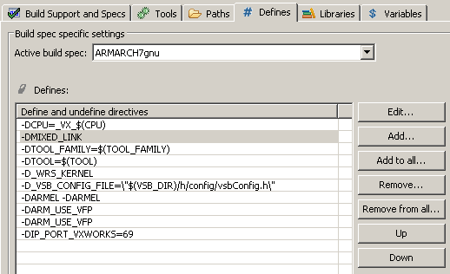

iv. Change to „Build Paths“ Tab

v. Add the following Build Paths to your configuration: 1. -I<path-to-runtime-interfaces>/Components

2. -I<path-to-runtime-interfaces>/Platforms/VxWorks